**The University of Nottingham**

**Faculty of Engineering**

**Department of Electrical and Electronic Engineering**



**EEEE3026**

**Project Outline and Planning Report**

**WellnessAI+: Elevating Mental, Emotional and Physical Health with ECG-Enhanced Artificial intelligence**

AUTHOR : KOAY XIAN CONG

ID : 20418760

SUPERVISOR : DR HERMAWAN NUGROHO

MODERATOR : PROF T. NANDHA KUMAR

DATE : 30th OCT 2023

**Contents**

1. Overview of the Project 3

2. Specification 7

3. Methodology 10

4. Risk Management and Mitigations 13

5. Time Plan 16

6. References 18

7. Appendix 20

# Overview of the Project

**Introduction**

The focus of this project is to incorporate electrocardiogram (ECG) and artificial intelligence (AI) driven algorithms to offer a groundbreaking approach to edge computing to not only predict heart disease but also delve into the depths of human emotions. In this era of smart wearables, the integration of ECG with AI technology holds the potential to revolutionize the way we understand, monitor, and manage both our physical and emotional well-being. This dual-purpose capability signifies a pivotal leap forward in personalised healthcare and wellness management, ushering in a new era of preventative and predictive medicine. The deployment of AI into edge computers powered by ARM Cortex-M chips will also be further explored and discussed.

**Problem Statement**

Latterly, there has been growing acknowledgement of the significant impact that mental health has on the attainment of global development objectives, which has been illustrated by the incorporation of the Sustainable Development Goals. According to the World Health Organization (WHO), depression stands out as a major contributor to disability, while suicide ranks fourth leading cause of death among individuals aged 15 to 29. [1] Although there have been advancements made towards mental health issues, individuals dealing with mental health issues frequently encounter serious infringements of their human rights, discrimination, and social stigma. [1]

An electroencephalogram (EEG) is a commonly utilized tool to diagnose and measure the electrical activity in the brain. It involves the use of electrodes placed on the scalp to detect and monitor the brain’s electrical impulses and patterns of activity. The resulting data is typically displayed as a series of waveforms and is used to assess brain function, diagnose various neurological conditions, and study brain activity in research settings. EEGs are commonly employed in clinical medicine to aid in the diagnosis and management of conditions such as epilepsy, seizure disorders, emotions, stress levels, etc. Since EEG is a valuable tool, there are a lot of researchers incorporating EEG as a reliable tool to detect and recognize emotion. However, since EEG electrodes need to have good contact with the scalp to capture accurate brainwave data, achieving consistent and reliable contact with the scalp is difficult in a wearable form factor. Movements and shifts in the device, as well as hair interference, can affect the quality of EEG signals. EEG devices may be uncomfortable, inconvenient and expensive for regular use. [2]

Mental health aside, cardiovascular disease (CVDs) stands as the primary global cause of mortality, claiming around 17.9 million lives annually according to WHO. [3] More than 80% of CVD-related deaths result from heart attacks and strokes, with one-third occurring prematurely in individuals under 70 years of age. [3]

An electrocardiogram (ECG) can perform a simple test that records the electrical activity of the heart over a period. It is a widely used diagnostic tool to assess the heart’s rhythm and electrical conduction. The test is typically performed using electrodes placed on the skin’s surface at specific locations on the chest, arms, and legs. These electrodes detect the electrical signals generated by the heart as it beats and transmit the information to an ECG sensor, which then produces a visual representation of the heart’s electrical activity in the form of a graph or a series of waves. ECG can provide vital information about various aspects of cardiac health, including heart rate, the regularity of heartbeats, signs of abnormal rhythms, and the presence of certain heart conditions, such as ischemia or structural abnormalities. [4] Since ECG is a valuable tool used for diagnosing and monitoring heart-related issues and is commonly used in medical settings, there is a wide array of studies performed on enhancing ECG with Artificial Intelligence on heart disease analysis and prediction.

**Background Information**

Electrocardiogram (ECG)

An ECG is utilized as a medical test instrument that measures and records the electrical activity of the heart over a period. It provides medical professionals with several vital purposes such as diagnosing heart conditions, monitoring heart issues, etc. A sample signal of the ECG wave is shown in Figure 1. The P-wave represents the electrical signal when the atria contract and push blood into the ventricles. [5] The inter-beat interval (IBI) is used for detecting heart rate, which can be computed based on the distance between R peaks in the ECG waveforms. [6] The QRS complex shows the electrical activity when the ventricles contract to pump blood out to the body. [5] Finally, the T-wave is the recovery phase when the heart’s electrical system gets ready for the next beat. The standard placement of ECG is shown in Figure 2.

Autonomic Innervation of the Heart

According to Anatomy and Physiology 2, there are physiological interrelations between the heart and brain. [7] The autonomic innervation of the heart is a crucial part of the Autonomic Nervous System (ANS), which regulates involuntary bodily functions, including heart rate, blood pressure and respiratory rate. The regulation of heart rate is centred in the paired cardiovascular control centres within the medulla oblongata of the nervous system which are the sympathetic nervous system and the parasympathetic nervous system as shown in Figure 3. [7] While at rest, both centres offer subtle stimulation to the heart, contributing to the autonomic tone. The cardio accelerator triggers the release of the neurotransmitter norepinephrine, leading to a significant rise in heart rate, which takes place in both the sympathetic nervous system (SNS) and the sinoatrial (SA) node, while the cardioinhibitory release the neurotransmitter acetylcholine (Ach) into the parasympathetic nervous system (PNS). [7] The ANS would react based on the situation and alterations in the emotional experiences. For instance, a cardioaccelerator will be triggered in a “flight-or-fight” situation [8] whenever a person is in danger. Thus, when emotions are experienced, this interaction between the heart and brain can lead to certain changes or variations in how those emotions are felt or expressed. Hence, emotional experiences are not only influenced by our thoughts and feelings but also by the physiological interplay between heart and brain.

Arrhythmia

As discussed in the problem statement, CVDs contribute a significant amount of mortality. One of the approaches to detect arrhythmia is to use ECG. [9] Arrhythmia refers to an irregular or abnormal heartbeat. [10] The heart typically beats in a regular, rhythmic pattern to pump blood throughout the body which can be shown in the ECG waveform in Figure 1. In instances of arrhythmia, the heart can exhibit deviations in its rhythm, which may denote as excessive speed, rhythm or irregular pattern. [11] The severity of this condition varies, ranging from benign to life-threatening, depending on its specific type and its impact on an individual’s overall well-being. Arrhythmias may lead to symptoms such as palpitations, dizziness, breathlessness, or chest discomfort. [12] Thus, accurate diagnosis and monitoring of arrhythmias are essential to maintain good heart health.

**Consumer Demand**

To develop a wearable that can perform real-time emotion recognition on the edge as well as perform heart disease prediction on the cloud, the system needs to be accurate and lightweight. [5] Moreover, as stated in the problem statement, both mental and physical health contributed a significant amount of mortality based on statistics given by WHO. Based on a national survey performed in the US, roughly 30% of American adults make use of healthcare wearable devices. [13] Among these users, about 47.33% use these devices daily, and a significant majority, representing 82.38%, express their willingness to share the health data collected from these wearables with their healthcare providers, emphasizing the potential for healthcare professionals to access vital information for better-informed medical decisions. [13] Thus, based on the potential number of users available, it reveals a compelling case for the development and commercialization of healthcare wearables which ultimately enhance the overall quality of healthcare services.

**Aim**

The objective of this project is to create a health monitoring system that integrates an ECG measurement kit with an STM32 edge computer and a cloud-based computer. This system comprises two key components: a model for predicting heart disease (cloud computer) and another for real-time emotion recognition (edge computer). The most important goal is to design a circuit that captures bioelectric signals from the heart accurately. Next, a data processing method to acquire features with physiological and physical significance needs to be designed. [2] This innovative approach allows users to not only track their physical health but also their mental well-being. Additionally, the project explores the utilization of Intel OpenVINO as a model optimizer and hardware accelerator, facilitating the deployment of AI models without the need to modify the underlying code. The model for real-time emotion recognition needs to be lightweight enough to be embedded into a device to implement edge computing. [2] [5]

This project holds significant importance in the realm of healthcare technology. Combining ECG measurement with advanced AI models, it offers a holistic approach to health monitoring, addressing both physical and emotional aspects. The ability to predict heart disease can lead to early intervention and potentially life-saving measures. Real-time emotion recognition can aid in mental health support, especially in times when stress and emotional well-being are increasingly critical. The use of Intel OpenVINO streamlines the deployment of AI models, making this technology more accessible and adaptable for a wide range of applications.

**Block Diagram**

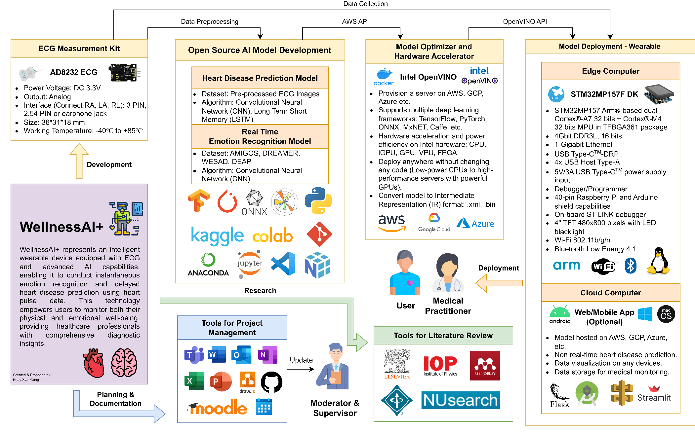

# Specification

**Hardware**

**Requirements:** Setting up STM32MP157F DK edge computer.

**Priority:** High

**Standards & Practices:** Follow the manufacturer’s guidelines or hardware setup and ensure electrical safety protocols.[14]

**Tests:**

1. Conduct a power-on test.
2. Validate hardware connections.
3. Verify the functionality of essential components.

**Success Measure:** Successful boot-up and initialization of STM32MP157F DK with no hardware and electrical issues.

**Attainability and Achievability:** Achievable with the necessary resources and adherence to the manufacturer's instructions. [14]

**Requirements:** Integrating ECG measurement kit onto edge computer.

**Priority:** High

**Standards & Practices:** Ensure secure and accurate data transmission, and compliance with medical data protection standards.

**Tests:**

1. Verify data connection between the ECG kit and edge computer.
2. Confirm data accuracy.

**Success Measure:** Successful integration with consistent, accurate ECG data transmission.

**Attainability and Achievability:** Achievable with appropriate hardware interfaces and software development.

**Requirements:** Create a real-life model of the wearable designed to integrate both software and hardware onto it.

**Priority:** Low (Stretch goal)

**Standards & Practices:** Utilize ergonomic design to ensure user comfort and safety.

**Tests:**

1. Conduct usability tests with potential users.
2. Assess integration of hardware and software components into the wearables.

**Success Measure:** Positive feedback from users on functionality and design.

**Attainability and Achievability:** Challenging but attainable as a stretch goal, may require additional resources and time.

**Software**

**Requirements:** Setting up applications and tools for software development.

**Priority:** High

**Standards, Practices and Licenses:** Follow industry best practices, and adhere to software development guidelines and licensing agreements. Use open-source tools and software.

**Tests:**

1. Ensure proper installation of development tools.
2. Run initial tests to confirm they function as intended.

**Success Measure:** Successful setup of software development environment without any critical issues.

**Attainability and Achievability:** Achievable with the necessary software and resources.

**Requirements:** Coding program to familiarize and test functions of edge computer and ECG.

**Priority:** Medium

**Standards, Practices and Licenses:** Adhere to coding and programming best practices, ensure modularity and standardization of code, and follow any relevant licenses for code libraries. Use open-source libraries.

**Tests:**

1. Run test cases to confirm the functionality of the edge computer and ECG components.

**Success Measure:** Successful development of a program that effectively tests and familiarizes with edge computer and ECG.

**Attainability and Achievability:** Achievable with the necessary programming skills and resources.

**Requirements:** Coding program to test ECG sensor.

**Priority:** Medium

**Standards, Practices and Licenses:** Adhere to coding and programming best practices, ensure modularity and standardization of code, and follow any relevant licenses for code libraries. Use open-source libraries.

**Tests:**

1. Conduct tests and experiments to verify the accuracy and reliability of ECG sensor data.

**Success Measure:** A program that effectively tests the ECG sensor and provides reliable data.

**Attainability and Achievability:** Achievable with the necessary programming skills and resources.

**Requirements:** Designing wearables to integrate edge computer and ECG sensors.

**Priority:** Low (Stretch goal)

**Standards, Practices and Licenses:** Follow wearable design best practices, and consider safety and user comfort.

**Tests:**

1. Conduct usability tests with potential users.
2. Assess integration of hardware and software components into the wearable.

**Success Measure:** Positive feedback on the design and functionality of the integrated wearable.

**Attainability and Achievability:** Challenging but attainable as a stretch goal, may require additional design and engineering resources.

**Requirements:** Coding program to create and test heart disease prediction model.

**Priority:** High

**Standards, Practices and Licenses:** Adhere to coding and programming best practices, ensure modularity and standardization of code, and follow any relevant licenses for code libraries. Use open-source libraries and datasets.

**Tests:**

1. Conduct tests to verify the accuracy and effectiveness of the heart disease prediction model.

**Success Measure:** A functional program that successfully creates and tests the heart disease prediction model.

**Attainability and Achievability:** Achievable with the necessary programming skills and resources.

**Requirements:** Coding program to create and test emotion recognition model.

**Priority:** High

**Standards, Practices and Licenses:** Adhere to coding and programming best practices, ensure modularity and standardization of code, and follow any relevant licenses for code libraries. Use open-source libraries and datasets.

**Tests:**

1. Conduct tests to verify the accuracy and effectiveness of the emotion recognition model.

**Success Measure:** A functional program that successfully creates and tests the emotion recognition model.

**Attainability and Achievability:** Achievable with the necessary programming skills and resources.

**Requirements:** Implementing Intel OpenVINO as a model optimizer and hardware accelerator.

**Priority:** Medium

**Standards, Practices and Licenses:** Follow the manufacturer’s guidelines, and comply with relevant licensing agreements.

**Tests:**

1. Validate the performance improvement achieved through OpenVINO optimization.

**Success Measure:** Successful integration and performance improvement using Intel OpenVINO.

**Attainability and Achievability:** Achievable with access to OpenVINO resources and appropriate hardware.

**Requirements:** Setting up and deployment of heart disease prediction model in cloud computer.

**Priority:** Medium

**Standards, Practices and Licenses:** Ensure cloud deployment adheres to security and privacy standards and complies with licensing agreements.

**Tests:**

1. Validate the successful deployment and functioning of the heart disease prediction model in the cloud.

**Success Measure:** Successful deployment of the model in the cloud environment with proper functionality.

**Attainability and Achievability:** Achievable with access to cloud computing resources and expertise.

**Requirements:** Deployment of emotion recognition model in edge computer.

**Priority:** Medium

**Standards, Practices and Licenses:** Ensure compliance with edge computing best practices and relevant licenses.

**Tests:**

1. Confirm that the emotion recognition model works effectively on the edge computer.

**Success Measure:** Successful deployment of the model on the edge device with proper functionality.

**Attainability and Achievability:** Achievable with the necessary edge computing resources and expertise.

**Requirements:** Coding program to display data collected from sensor and model output result.

**Priority:** Low (Stretch goal)

**Standards, Practices and Licenses:** Follow best practices for data visualization and ensure compliance with relevant licenses. Use open-source libraries.

**Tests:**

1. Validate the program’s ability to display sensor data and model output results effectively.

**Success Measure:** Development of a program that successfully displays sensor data and model output results.

**Attainability and Achievability:** Achievable as a stretch goal, may require additional software development resources.

# Methodology

**Step 1:** Setting up software and hardware for STM32MP157F-DK2.

**Relevant tools, Justification & Limitations:**

1. STM32MP157F-DK2. [14]

* Powerful hardware: Powered by a dual-core ARM Cortex-A7 CPU with an ARM Cortex-M4 microcontroller, it is power-efficient and suitable for real-time tasks.
* Power efficiency: STM32MP1 microprocessors are designed for low power consumption, making them well-suited for battery-powered or wearable devices.
* Real-time capabilities: The presence of an ARM Cortex-M4 microcontroller on the edge computer allows for real-time control and signal processing, which can be crucial for the deployment of real-time emotion recognition.
* Customization: Comes with a 4” TFT 480x800 pixels with LED backlight, allowing data collected and model output to be displayed.

Limitations:

* Compared to Raspberry Pi, STM32MP157F-DK2 has fewer readily available resources and support due to smaller communities.
* STM32MP157D-DK2 is less common and requires sourcing from specific distributors.

1. VirtualBox to run Ubuntu OS.

* Compatibility: The STM32 Cube Programmer has better compatibility with a Linux environment since the documentation given is in Ubuntu OS. This ensures that it functions smoothly without any compatibility issues.

Limitations:

* Virtualization introduces overhead, which can impact the overall performance of running STM32 Cube Programmer and other applications.
* USB passthrough may not work seamlessly with all STM32 devices or programming and debugging tools.
* The STM32 Cube Programmer relies on USB drivers and hardware communication. Virtualized environments can sometimes be less compatible with specialized drivers, leading to connectivity and communication problems with STM32 devices.

1. STM32 Cube programmer. [14]

* Official tool by STMicroelectronics: STM32 Cube Programmer is developed and maintained by the manufacturer, ensuring compatibility and reliability.
* Integrated Development Environment: STM32 Cube Programmer is part of the STM32Cube ecosystem, which provides a comprehensive set of development tools for STM32 microcontrollers and microprocessors. It integrates well with other STM32Cube tools and libraries, streamlining the development process.
* Programming and debugging: It offers a user-friendly interface for programming STM32 devices, which can include flashing firmware, configuring settings, memory management, and debugging applications.

Limitations:

* STM32 Cube Programmer can be resource-intensive, particularly when working with large projects.

**Potential Additional Tasks:** Familiarize with Ubuntu OS and STM32 Cube programmer.

**Step 2:** Integrating ECG kit onto edge computer.

**Relevant tools, Justification & Limitations:**

1. AD8232 ECG measurement kit. [15]

* Data collection: The ECG measurement kit is chosen for its accuracy and precision in collecting vital heart activity.

Limitations:

* Ensuring seamless compatibility between the ECG kit into the edge computer may be technically challenging and may require expertise in hardware interfacing.
* Wearable ECG sensors may not be as comfortable for long-term use, potentially affecting user adoption and compliance.

**Potential Additional Tasks:**

* Perform tests and experiments to verify that the ECG kit is functioning correctly and can collect ECG data accurately.
* Implementation of data transmission protocols to ensure that ECG data collected by the kit can be transmitted to the edge computer in real time.

**Step 3:** Open-Source AI Model Development.

**Relevant tools, Justification & Limitations:**

1. Python and machine learning (ML)/deep learning (DL) libraries (NumPy, Matplotlib, etc.).

* Open source: Python is a widely used programming language for ML and DL. It has various libraries available for data manipulation, analysis, visualization, etc in AI model development.

Limitations:

* Advanced DL models may require substantial computational resources, which could impact performance on resource-constraints systems.

1. Anaconda/Google Colab.

* Local training: Anaconda provides a convenient environment for managing Python packages and creating isolated development environments. Since there are 2 models developed: heart disease prediction and emotion recognition, this feature ensures package compatibility between projects.
* Cloud training: Google Colab is a cloud-based platform that offers free GPU and TPU resources for training DL models, reducing the need for computational power.

Limitations:

* The availability of free resources on Google Colab may be limited, and reliance on cloud-based resources may have data privacy and internet connectivity considerations. Running DL models locally requires a lot of computational power and time.

1. Deep learning libraries (TensorFlow/PyTorch, etc.).

* Pre-built neural network architectures: Enabling AI model development more accessible and efficient with optimization tools and GPU acceleration available.

Limitations:

* Implementing complex neural network architecture requires expertise in DL, and training large models may demand significant computational resources.

1. Git/GitHub.

* Efficient: Version control system that allows for efficient version tracking in AI model development.

Limitations:

* Managing large datasets or models within Git repositories can be challenging, and it’s important to follow best practices to avoid repository bloat.

**Potential Additional Tasks:**

* Familiarize with software tools and DL models.
* Perform data preprocessing, which may involve tasks like data augmentation, normalization, and feature extraction, to prepare the input data for the AI model.
* Retrain model available online to validate the accuracy and performance of the model.

**Step 4:** Model Optimizer and Hardware Accelerator.

**Relevant tools, Justification & Limitations:**

1. Intel OpenVINO Toolkit.

* Compatibility: Supports multiple DL frameworks (TensorFlow, PyTorch, etc.).
* Performance: Enhance the performance and efficiency of AI models, allowing them to run seamlessly on Intel-based hardware.
* Code reusability: Deploy anywhere without changing any code.

Limitations:

* Depending on the complexity of the AI models and the specific hardware accelerators used, there may be some steep learning curve and resource req to effectively utilize the Intel OpenVINO Toolkit.

**Additional Tasks:**

* Familiarize with Intel OpenVINO Toolkit.
* Configure and optimize AI models using the Intel OpenVINO Toolkit for deployment on the STM32MP57F-DK2 hardware accelerator and assess the performance improvements achieved through model optimization.

**Step 5:** Deployment of AI models into edge computers and cloud computers.

**Relevant tools, Justification & Limitations:**

1. Edge Computer (STM32MP157F).

* As discussed above.

1. Cloud Computer (AWS, Azure, GCP).

* Scalable resources: Cloud platforms offer scalable compute resources, allowing for the deployment of large and complex AI models.
* High-performance GPU: Cloud providers often offer access to powerful GPU instances, which can significantly accelerate AI model inference and training.
* Deployment into Web/Mobile apps: Cloud providers offer APIs to link the results onto frontend web/mobile apps.

Limitations:

* AI models deployed in the cloud may experience network latency, which can be a concern for real-time applications.
* AI models deployed in the cloud may experience network latency, which can be a concern for real-time applications.

**Potential Additional Tasks:**

* Ensure that the AI models are optimized for deployment on both the edge computer and the cloud platform.

# Risk Management and Mitigations

**Step 1:** Setting up software and hardware for STM32MP157F-DK2.

1. **Risk:** Limited Community Support: Difficult to get support when issues arise.

**Mitigation:** Establish direct contact with STM32MP157F-DK2 user forums, seek expert advice, and build a network of contacts for troubleshooting.

**Impact:** Limited community support may result in longer issue resolution times.

**Likelihood:** Medium

1. **Risk:** Hardware Compatibility: Incompatibility issues between the STM32MP157F-DK2 and the ECG measurement kit may arise.

**Mitigation:** Prior to integration, perform compatibility testing, and refer to hardware documentation.

**Impact:** Delay in project timeline.

**Likelihood:** Low

1. **Risk:** Human error: Short circuit due to incorrect power connections.

**Mitigation:** Supply power and connect peripherals to the edge computer by adhering to the documentation and requirements.

**Impact:** Delay in project timeline if new microcontroller order is needed.

**Likelihood:** Low

**Step 2:** Integrating ECG kit onto edge computer.

1. **Risk:** Health and safety issue: ECG sensor being tested on real-life human needs to adhere to health and safety compliance.

**Mitigation:** The subject’s skin needs to be wiped with alcohol before snap on electrode is applied. [2]

**Impact:** Health and safety issues can lead to ethical and legal concerns, project delays, and potential health risks to human subjects.

**Likelihood:** High

**Step 3:** Open-Source AI Model Development

1. **Risk:** Computational Resources: Advanced deep learning models may require substantial computational resources, impacting project performance on resource-constrained systems.

**Mitigation:** Optimize and simplify AI models, employ cloud-based resources when necessary, and manage hardware efficiently.

**Impact:** Delayed model training, and performance degradation.

**Likelihood:** High

1. **Risk:** Data Privacy: Reliance on cloud-based resources may raise security concerns.

**Mitigation:** Implement data encryption, access control, and ensure compliance with data protection regulations. Use open-source datasets.

**Impact:** Data breaches, legal liabilities.

**Likelihood:** High

1. **Risk:** Model detection: An exclusive reliance on deep learning methods proved insufficient in identifying all crucial ECG signal features. [5] [11]

**Mitigation:** Hybrid strategy is applied to improve detection efficiency. [5]

**Impact:** Inefficient model detection can lead to inaccurate results and potentially harmful misdiagnoses.

**Likelihood:** High

1. **Risk:** Dataset Requirement: ECG signal analysis demands a substantial volume of data for accurate results, increasing the risk of misdiagnosing specific heart conditions. [11]

**Mitigation:** Adequately address data volume requirements by ensuring the dataset size is sufficient for the AI models' training and validation processes. Performing data augmentation to increase the size of the dataset available.

**Impact:** Inadequate data volume can lead to misdiagnoses and reduce the AI model's effectiveness.

**Likelihood:** High

1. **Risk:** Dataset Availability: Discovering a comprehensive framework with corresponding standards accessible to the general population is a complex task. [11]

**Mitigation:** Explore various sources, including open-source datasets to gather a diverse and representative ECG dataset. Ensure compliance with data protection regulations.

**Impact:** Limited or inadequate dataset availability can hinder AI model development and testing.

**Likelihood:** High

1. **Risk:** Human factors: Age, gender, physical health, and lifestyle exert an influence on the amplitude and duration of individuals' ECG readings. [11]

**Mitigation:** Focus on a specific group of users and reduce the range of demographic groups.

**Impact:** Failure to account for human factors can lead to biased or unreliable AI models.

**Likelihood:** Medium

1. **Risk:** Wearable deployments: Physical activity, such as running, walking, and sleeping can affect the ECG signal’s morphology, contributing to signal noise. [11]

**Mitigation:** Develop noise-filtering algorithms and signal-preprocessing techniques to enhance the quality of ECG data collected from wearable devices.

**Impact:** Failure to address signal noise can lead to inaccurate ECG signal analysis.

**Likelihood:** Medium

**Step 4:** Model Optimizer and Hardware Accelerator

1. **Risk:** Learning Curve: Utilizing the Intel OpenVINO Toolkit effectively may require a steep learning curve.

**Mitigation:** Invest time in training and tutorials, seek expert assistance, and start with smaller, well-documented models.

**Impact:** Delays in model optimization, increased development time.

**Likelihood:** Medium

1. **Risk:** Resource Requirements: Depending on the complexity of AI models and the specific hardware accelerators used, resource requirements may be higher than anticipated.

**Mitigation:** Conduct thorough resource planning, allocate sufficient resources, and monitor utilization.

**Impact:** Performance bottlenecks, potential project overruns.

**Likelihood:** Medium

**Step 5:** Deployment of AI models into edge computer and cloud computer

1. **Risk:** Real-Time Edge Deployment Challenges: The model takes too long to produce output.

**Mitigation:** Rigorously test AI model deployment on the STM32MP157F-DK2 to ensure real-time performance and functionality.

**Impact:** Real-time deployment issues can lead to model inaccuracies and reduced usability.

**Likelihood:** High

1. **Risk:** API and Compatibility Challenges: AI models developed are difficult to implement into edge and cloud computers due to API and compatibility issues.

**Mitigation:** Perform test cases with available AI models before training a new model.

**Impact:** Delay in project timeline.

**Likelihood:** High

1. **Risk:** Network Latency: AI models deployed in the cloud may experience network latency.

**Mitigation:** Optimize model size, employ edge computing where possible, and implement network performance enhancements.

**Impact:** Delayed response times.

**Likelihood:** Medium

1. **Risk:** User comfort in wearable deployments: Wearable ECG sensors may not be comfortable for extended use, potentially impacting user compliance.

**Mitigation:** Conduct user testing, gather feedback, and refine the design to enhance user comfort.

**Impact:** Reduced user adoption, less reliable data.

**Likelihood:** Medium

1. **Risk:** Cost Overruns: Cloud-based deployment can incur unexpected costs, especially for resource-intensive AI models.

**Mitigation:** Implement cost monitoring and budgeting, choose cost-efficient configurations, and regularly review usage.

**Impact:** Exceeding budget, financial strain.

**Likelihood:** Low

# Time Plan

The Gantt Chart for time planning has been structured considering the interdependencies between tasks. It consists of six primary tasks scheduled chronologically, which include:

1. Project planning,
2. Research and literature review,
3. Design solutions/applications,
4. Development of AI model,
5. Deployment of model and sensor into edge and cloud computer,
6. Thesis, documents and presentation.

Within the "Design solutions/applications" phase, there's a requirement to set up and test ECG sensors, STM32MP157F, and software. This precedes the design of the model architecture before moving on to the development of the AI model. The deployment of the model and sensor hinges on the completion of the AI model, so it follows this phase.

To ensure tasks stay on track, there are project milestones marked at various points, and four progress reviews are scheduled:

1. Moderator Review 1 (Week 9 – Week 10):

* Finalising Project Objectives and Project Specifications.
* Research and literature review.

1. Moderator Review 2 (Week 13 – Week 14):

* Coding program to test functions of edge computer.
* Coding program to test sensors and perform experiments to ensure accurate measurements of sensors.

1. Moderator Review 3 (Week 25):

* Coding program to develop emotion recognition model.
* Coding program to develop heart disease prediction model.
* Coding program to connect sensor with AI model.

1. Moderator Review 4 (Week 35 – Week 36):

* Integrating Intel OpenVINO model optimizer and hardware accelerator.
* Deploying heart disease prediction model developed onto cloud computer.
* Deploying emotion recognition model developed onto edge computer.
* Obtaining user experience, feedback and model prediction results.

In light of the potential risks and issues mentioned earlier, a parallelization technique is applied to enable the execution of multiple tasks simultaneously, particularly those that are independent of one another.

Additionally, provisions have been made for debugging codes and addressing bugs that may surface during model development and user testing. Improvements can be made based on feedback obtained from users.

The Gantt chart also incorporates error bars to account for uncertainties. In cases where previously unidentified risks arise, these error bars provide additional time to mitigate the issues.

Lastly, the Gantt chart includes optional and supplementary tasks, described as stretch goals, which can be pursued if there is available time before each progress review.

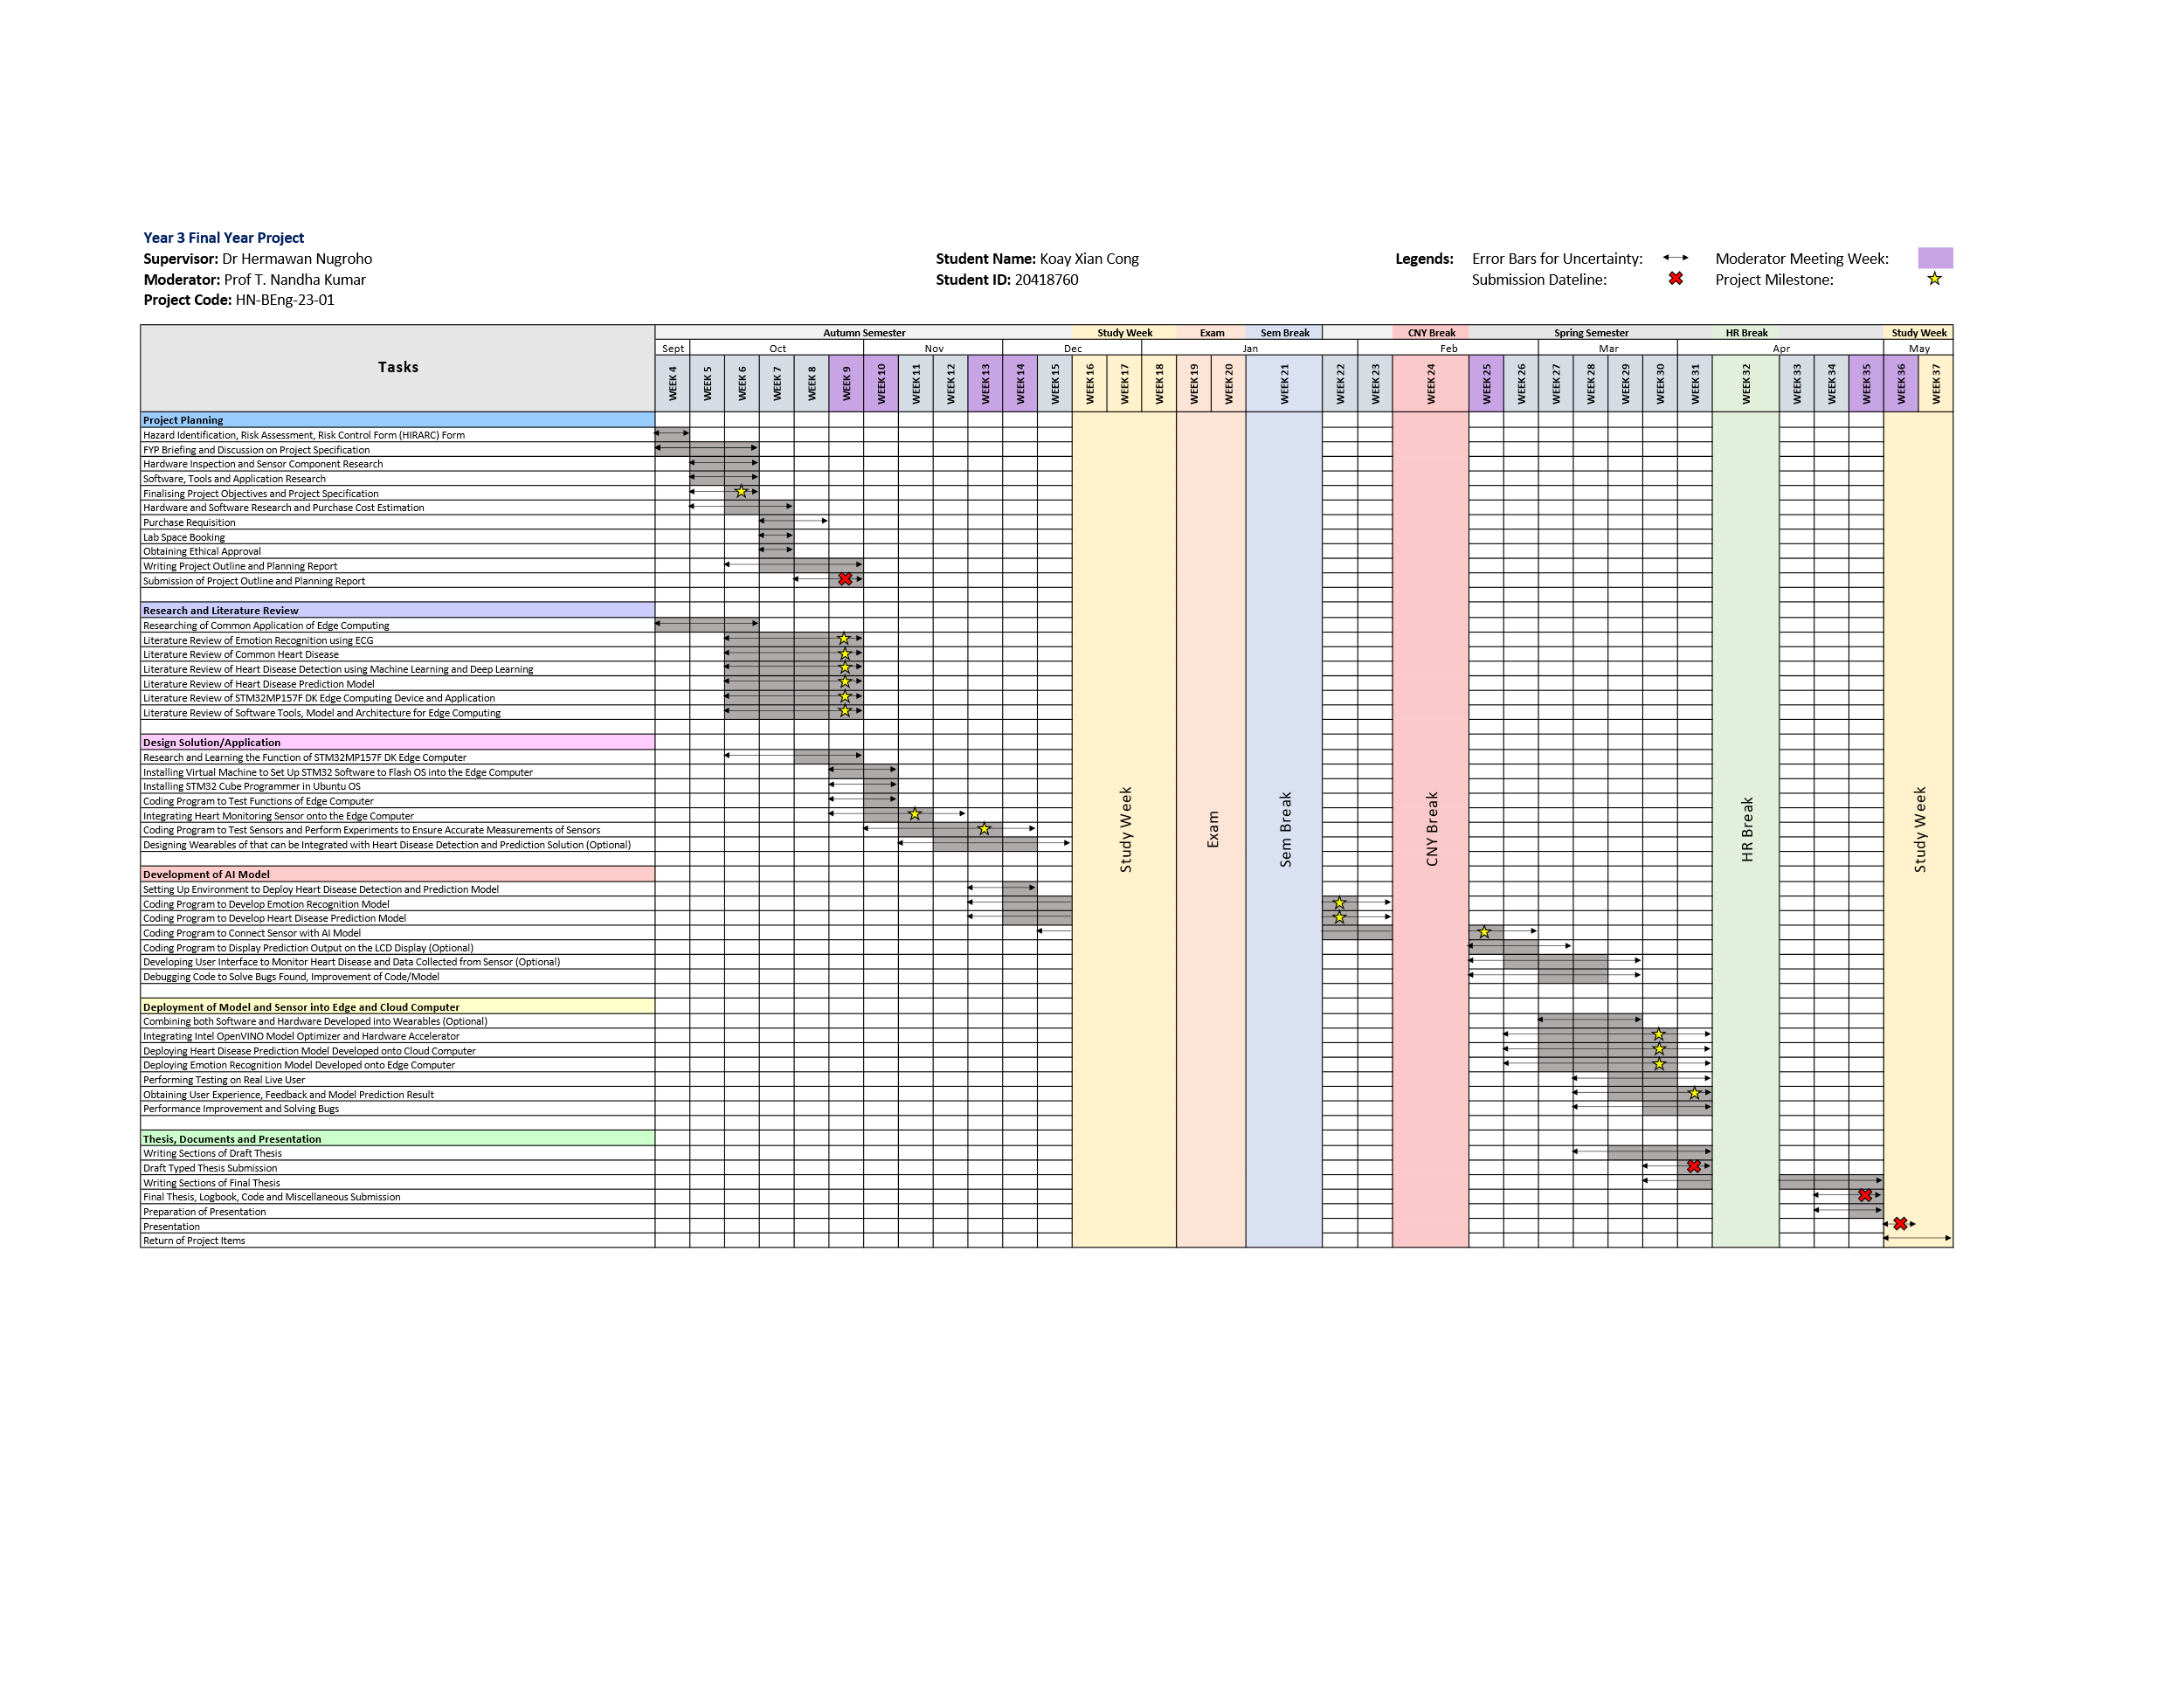**Gantt Chart**

# References

[1] “Mental health.” Accessed: Oct. 19, 2023. [Online]. Available: https://www.who.int/health-topics/mental-health#tab=tab_1

[2] X. Wang, J. Zhang, C. He, H. Wu, and L. Cheng, “A Novel Emotion Recognition Method Based on the Feature Fusion of Single-Lead EEG and ECG Signals,” *IEEE Internet Things J*, 2023, doi: 10.1109/JIOT.2023.3320269.

[3] “Cardiovascular diseases.” Accessed: Oct. 19, 2023. [Online]. Available: https://www.who.int/health-topics/cardiovascular-diseases#tab=tab_1

[4] Ed Burns and Mike Cadogan, “Myocardial Ischaemia • LITFL • ECG Library Diagnosis.” Accessed: Oct. 19, 2023. [Online]. Available: https://litfl.com/myocardial-ischaemia-ecg-library/

[5] A. L. Golande and T. Pavankumar, “Optical electrocardiogram based heart disease prediction using hybrid deep learning,” *J Big Data*, vol. 10, no. 1, pp. 139–13, 2023, doi: 10.1186/s40537-023-00820-6.

[6] A. Tjolleng *et al.*, “Classification of a Driver’s cognitive workload levels using artificial neural network on ECG signals,” *Appl Ergon*, vol. 59, no. Pt A, pp. 326–332, 2017, doi: 10.1016/j.apergo.2016.09.013.

[7] J. G. Betts *et al.*, *Anatomy & Physiology -OpenStax*. 2013.

[8] P. J. Bota, C. Wang, A. L. N. Fred, and H. Placido Da Silva, “A Review, Current Challenges, and Future Possibilities on Emotion Recognition Using Machine Learning and Physiological Signals,” *IEEE access*, vol. 7, pp. 140990–141020, 2019, doi: 10.1109/ACCESS.2019.2944001.

[9] H. Yang and Z. Wei, “Arrhythmia Recognition and Classification Using Combined Parametric and Visual Pattern Features of ECG Morphology,” *IEEE Access*, vol. 8, 2020, doi: 10.1109/ACCESS.2020.2979256.

[10] K. Subramanian and N. K. Prakash, “Machine learning based cardiac arrhythmia detection from ECG signal,” in *Proceedings of the 3rd International Conference on Smart Systems and Inventive Technology, ICSSIT 2020*, 2020. doi: 10.1109/ICSSIT48917.2020.9214077.

[11] T. Padma, A. Uday Kiran, C. Jahnavi, S. Rahul, N. Raja, and M. Kamal Kumar, “Detection and Classification of Arrhythmias by Deploying Deep Learning Models,” in *Journal of Physics: Conference Series*, 2022. doi: 10.1088/1742-6596/2325/1/012053.

[12] A. A. Salman and A. Ibarahim, “Detection of Cardiac Arrhythmias in Electroc Ardiograms Using Deep Learning,” in *ISMSIT 2022 - 6th International Symposium on Multidisciplinary Studies and Innovative Technologies, Proceedings*, 2022. doi: 10.1109/ISMSIT56059.2022.9932742.

[13] R. Chandrasekaran, V. Katthula, and E. Moustakas, “Patterns of Use and Key Predictors for the Use of Wearable Health Care Devices by US Adults: Insights from a National Survey,” *Journal of Medical Internet Research*, vol. 22, no. 10. 2020. doi: 10.2196/22443.

[14] “Unpack the STM32MP157x-DK2 board - stm32mpu.” Accessed: Oct. 22, 2023. [Online]. Available: https://wiki.st.com/stm32mpu/wiki/Getting_started/STM32MP1_boards/STM32MP157x-DK2/Let%27s_start/Unpack_the_STM32MP157x-DK2_board

[15] “Ks0261 keyestudio AD8232 ECG Measurement Heart Monitor Sensor Module - Keyestudio Wiki.” Accessed: Oct. 22, 2023. [Online]. Available: https://wiki.keyestudio.com/Ks0261_keyestudio_AD8232_ECG_Measurement_Heart_Monitor_Sensor_Module#Test_Result

[16] J. Gordon Betts *et al.*, *Anatomy and Physiology 2e*. Houston, Texas: OpenStax, 2022.

# Appendix

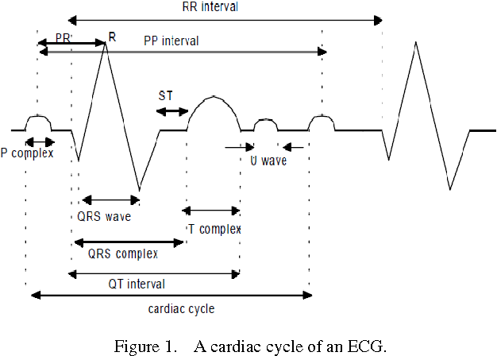

Figure 1. EEG cycle.

Figure 2. Standard placement of ECG. [16]

Figure 3. Autonomic Innervation of the Heart.

**Project Specifications**

